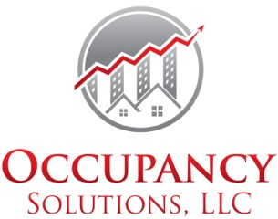
Increase Your Income & Reduce Your Vacancy

Annual turnover Percentage=
Total number of annual physical move outs ÷ total number of apartments

Average Effective Rent=
(Rental Income – Concession Rent) ÷ Units Occupied

NOI or Income or Projected Income or Benefit
÷ ÷
Value × Rate
Investment Capitalization Rate
Purchase Price Rate of Return
Overall Capitalization Rate

×

Closing Percentage or Ratio=
(Total number of leases for a period of time ÷ total number of traffic) x 100

Cost of Advertising per Lease=
Total cost of ad ÷ number of leases generated from ad

Cost of Advertising per Traffic=
Total cost of ad ÷ total number of traffic generated from ad

Gross Potential Rent (GRP or GPR)=
Add sum of all occupied units at current lease contract rates + all vacants units at market rents

Effective Rent=
(Market rent x number of months in lease term – total concession awarded) ÷ number of months in lease term

Effective Gross Income (EGI or Net Rental Income or Total Net Income)=
GPR – VAC (current month vacancy concessions, bad debt and non-revenue units)

Economic Occupancy Percentage=
EGI÷ GPR

Operating Expenses per Unit (annual)=
Total operating expenses ÷ toal number of units

Page Two

Gross Operating Income (GOI)=
Effective Gross Income + Operating Income

GOI – OI = EGI
GOI – EGI = OI

Operating Expense Ratio=
Operating Expense ÷ Gross Potential Rent x100

Net Operating Income (NOI)=
Total Income – total Operating Expenses
Or
Gross Operating Income – Operating Expenses

Break-even Occupancy Ratio=
(Operating Expense + Debt Service) ÷ Gross Operating Income

Break-even rent per square foot=
(Operating Expense + Debt Service) ÷ total square feet

Contact Occupancy Solutions for your solution today! 1-800-865-0948
www.occupancysolutionscom

